**Abandoned research facility research**

Rooms and interior design research

|  |  |
| --- | --- |
| Reception/lobby | Corridors |
| Conference Rooms | Elevators/stairs |
| Lounges/breakrooms for staff members | Research Labs |
| Offices | Canteen |
| Secret labs/torture rooms | Holding bays |

The rooms and features found inside facilities in general:

What rooms connect to each other and the most common in facilities:

Reception/lobby can connect to corridors, which then connects to all the other rooms.

Canteens can be on any floor but having them on the main floor would be the most likely.

On Higher levels, these could contain the labs where experiments will be done, offices and meeting rooms and lounges.

On Lower levels of the facilities the darker, more horrifying places can be found such as torture rooms, holding bays and other more secretive test labs.

**Examples of abandoned research facilities and How they can make our abandoned facility inside our game Lethe: agars island more realistic and more atmospheric.**

Abandoned facilities or other abandoned buildings have reasons why they have been left. This can be from company failure such as companies going bust, legal issues which could be with what the companies are using the buildings for, the buildings may have structural issues and many more.

In our game it will provide a facility which has been abandoned for reasons that are unknown but has something to do with the experiments and tests that people were doing inside our facility. To make the research help with our game, I have researched into real life examples of companies abandoning buildings, for similar reasons such as companies being bought down by law suits and merging with other companies as the chemicals they were producing were harming and contaminating the environment.

On the basis of current facilities, they follow a general rule of having similar features and if abandoned do not have maintenance, so is free to pests and even bigger animals making their way inside them, which could provide horror games with jump scares.

**Some sort of Entrance:**

(The Proper People, 2020)

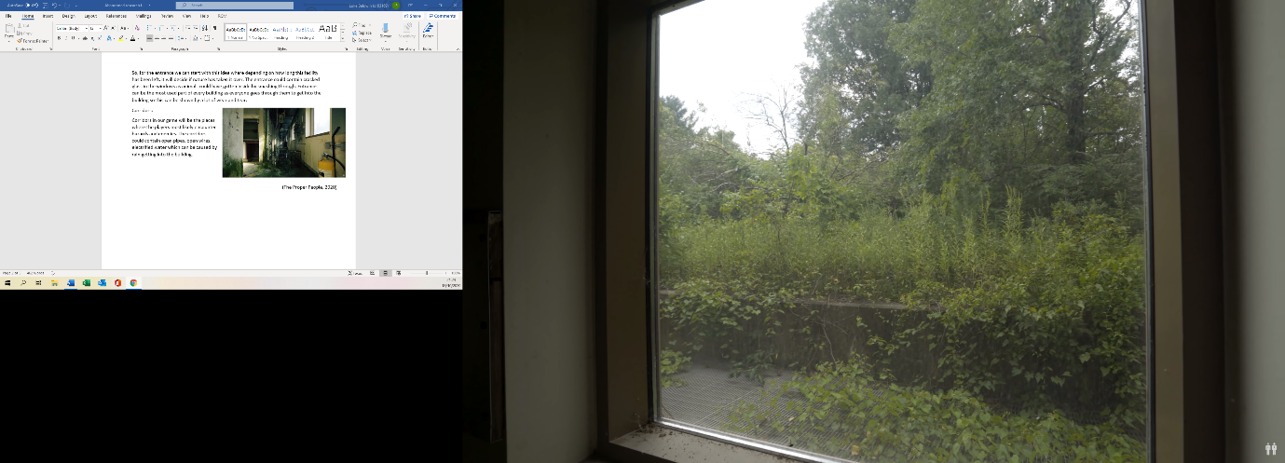As a building is abandoned there is no one to maintain it, in terms of outside the facility and inside. This gives the building to nature, where it grows uncontrollably inside ever gap possible.

Depending on how long a facility is left will determine exactly how much nature will have taken over. This is because eventually plant will grow through the floors and walls of a building.

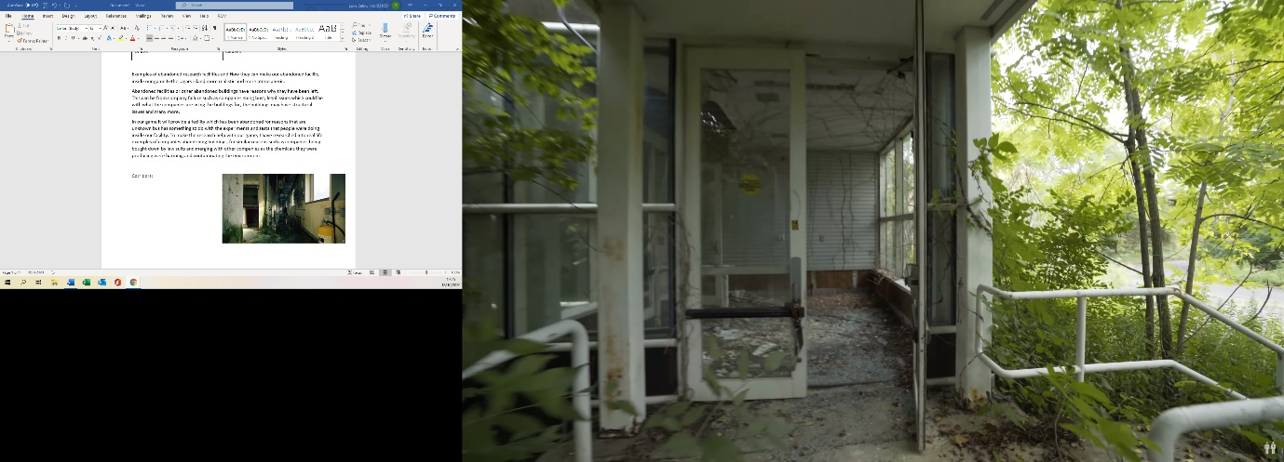So, for the entrance we can start with this idea were depending on how long this facility has been left, it will decide if nature has taken it over. The entrance could contain cracked glass in the windows as animals could have gotten inside by smashing through. Entrances can be the most used part of every building as everyone goes through them to get into the building so this can be shown by a lot of wear and tear.

(The Proper People, 2020)

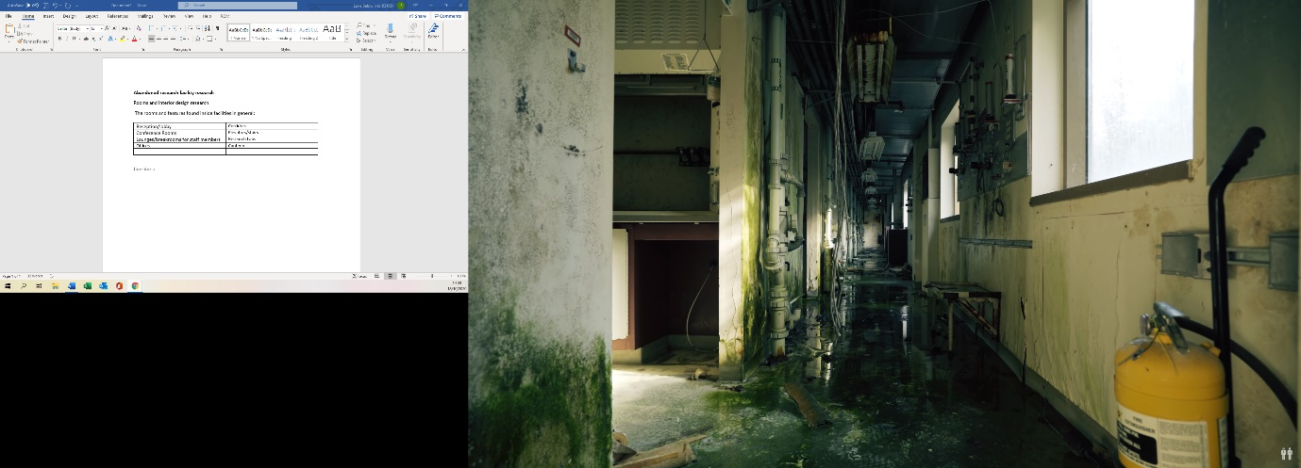

**Corridors:**

Corridors in our game will be the places where the players most likely encounter hazards and enemies. The corridors could contain open pipes, open wires, electrified water which can be caused by rain getting into the building.

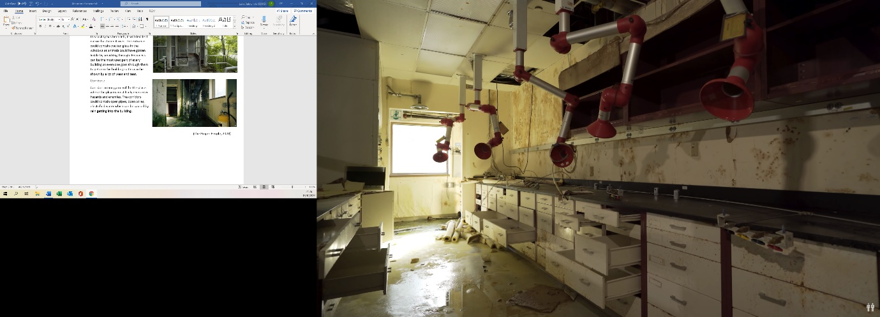**Laboratories:**

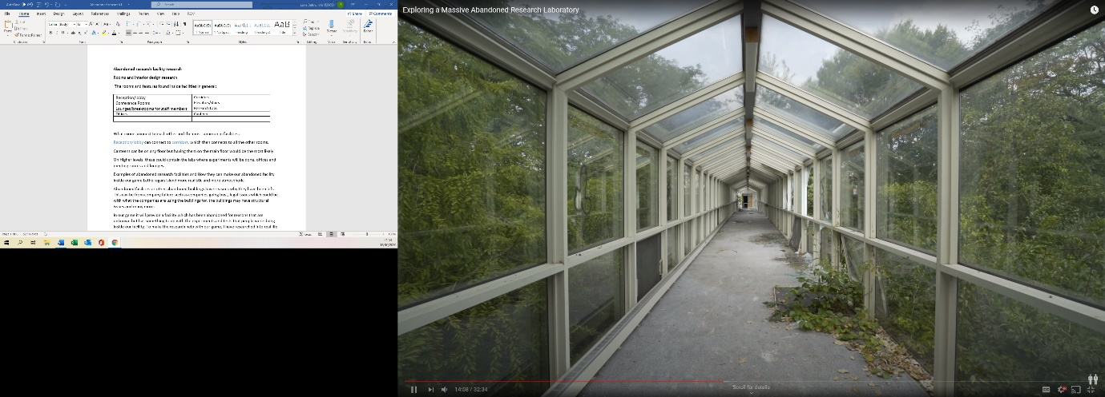In our game we can decide what we want inside our laboratories depending on the experiments that the people were doing before they left the facility. These laboratories could contain smashed test tubes, different types of materials such as metals and elements. As our main enemy is a gas monster, we could have gas cylinders in each laboratory which can be used for puzzles.

**Other passageways**: that could connect parts of the facility, these could be passageways that could unlock after puzzles are complete later in the game. If our game is an underground facility these could be underground glass passageways.

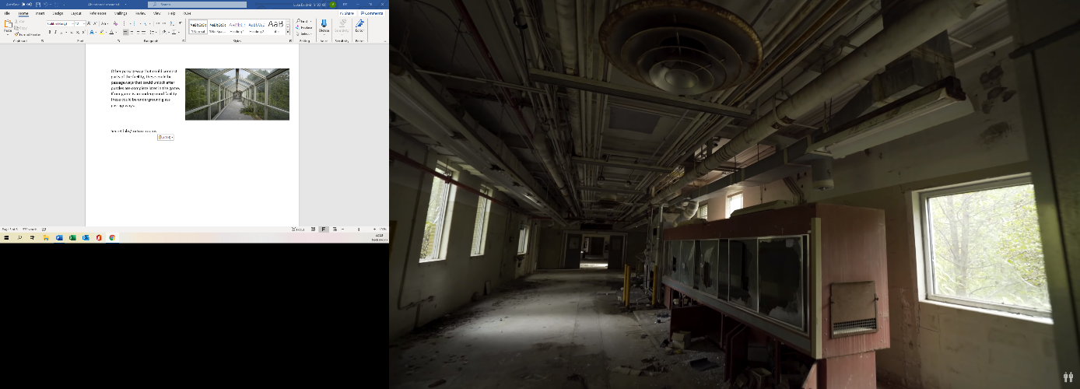

**Secret labs and torture rooms:**

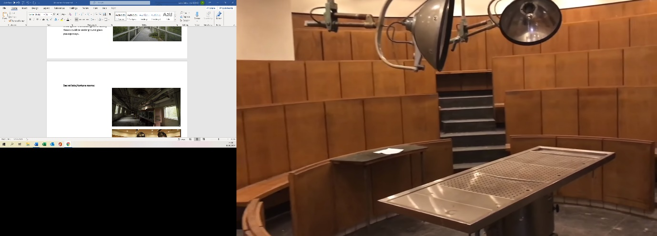These could be used to look like torture rooms in our game to add more dramatic effect but instead be something else entirely different. Depending on if the facility is underground or not will decide on what features we can include and the textures and scenery we can evolve in game play such as what can be seen outside widows.

(Strange Places, 2018)

Secret labs could provide players with collectables as these labs could be hidden away which are more difficult to find.

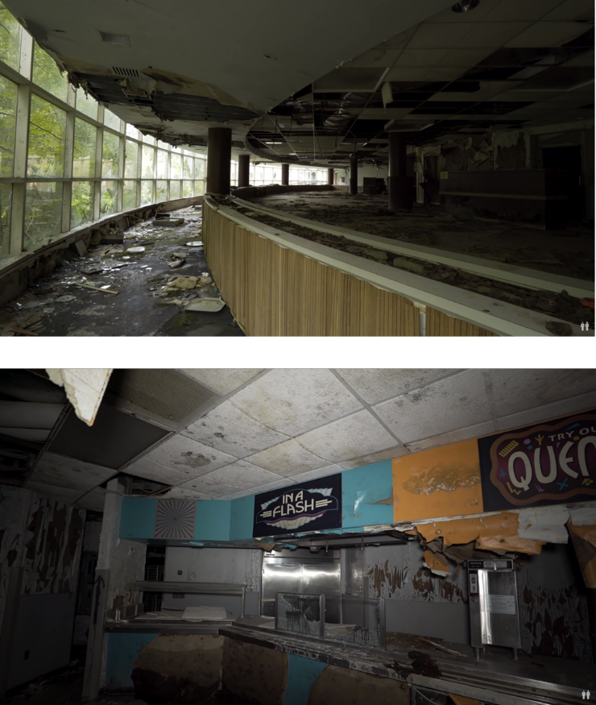**Cafeterias**

If our facility is located underground these cafeterias will contain more supplies as the facility is hidden where they want to limit the people that go in and out of this facility.

The café could be very gritty and horrible where food and horrible substances could be everywhere, especially in the cooking area itself.

As it abandoned there could be loads of out of date food that the player could interact with that could provide the player with more sanity or any different ways the player could interact with different objects.

**Holding bays**

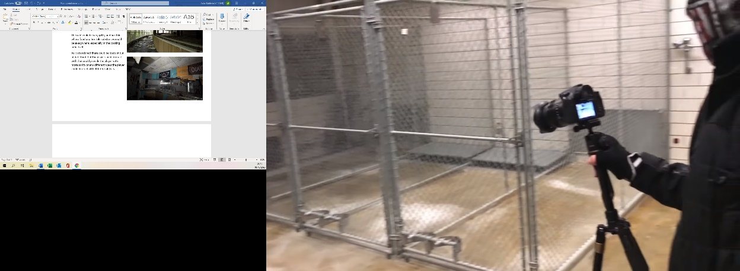These areas could be more horrified depending if anything has been left inside them. For our game as it is a part of the horror genre, could have these bays to contain animals/ other creatures where people get the idea that the facility were testing chemicals on them. To tell the player that the owners of the facility were testing and experimenting illegally and against human nature.

These holding bays could also contain collectables/ batteries for the torch used throughout gameplay

**Stairs/lifts**

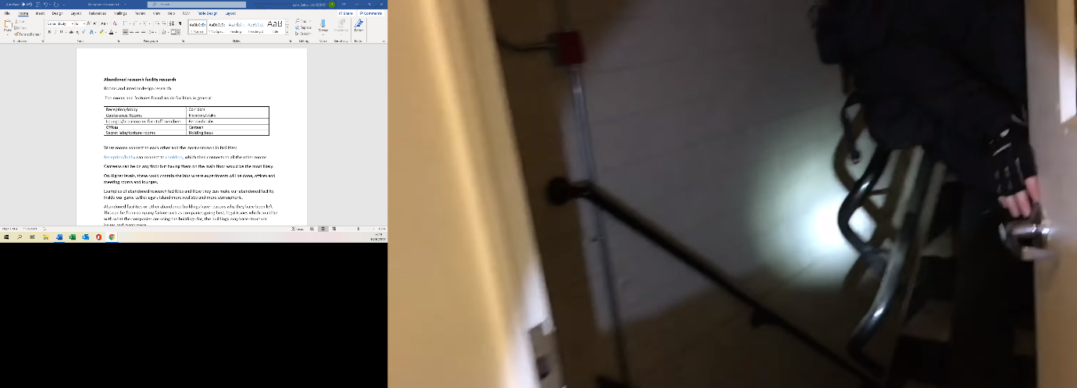As the game we are making takes place quite early in time 1900s and we want more chances of players taking the game slowly, where we want a lot of tension stairs could be the better way of getting to different floors. The stairs we could use could be really dark, in which a flashlight is needed to see would increase the levels of doubt and anxiety in the player, Due to not knowing what is around the corner.

1. The Proper People, 2020. Exploring A Massive Abandoned Research Laboratory. [video] Available at: <https://www.youtube.com/watch?v=ZZerv9umXuU&feature=emb_logo> [Accessed 18 October 2020].
2. Strange Places, 2018. SECRET ABANDONED RESEARCH LABORATORY (FOUND TUMORS, VACCINES, RADIOACTIVE ELEMENTS!). [video] Available at: <https://www.youtube.com/watch?v=UZX1pJG7vlE> [Accessed 18 October 2020].